and new year closure
The SPEAR team wishes all our stakeholders a memorable festive season with family and friends. We hope 2021 is healthy and prosperous for all.

SPEAR News
  - Surveying and Planning through Electronic Applications and Referrals

  - December 2020

This issue provides an update on current SPEAR activities and progress on other projects and businesses in Land Use Victoria (LUV). We also take the opportunity to reflect on some of our achievements during 2020.

SPEAR update

SPEAR Electronic Lodgment Network
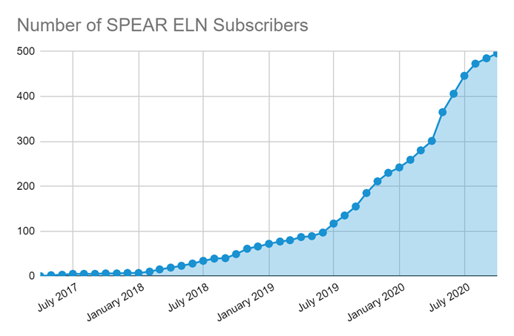
The SPEAR team has reached another significant milestone with 500 lodging parties signed up to the SPEAR Electronic Lodgment Network (ELN). There are a further 370 applications in progress.
The SPEAR ELN is now the primary method that conveyancers and lawyers use to lodge plan-based dealings at LUV. Approximately 70% of Subdivision Act 1988 lodgments now come through SPEAR.
The SPEAR team will be working with lodging parties that have not commenced or completed their SPEAR registration as LUV moves closer to achieving 100% electronic lodgment of plan-based dealings in SPEAR.

SPEAR Angular modernisation project
SPEAR Angular was released to users on 28 September 2020. This has been a major project with all SPEAR screens rebuilt to adapt to the new web development framework. Extensive user testing was undertaken by the team, with over 100 SPEAR users expressing interest to help test the beta version. The contribution of our users in this body of work was a clear example of the ongoing partnership we have with our stakeholder groups with the aim of continuing to provide a reliable system for all our users.

Online training for new and existing users
The delivery of SPEAR training evolved in 2020 with the Service Desk team changing all quarterly training sessions from onsite sessions at 2 Lonsdale Street to online sessions.
Online training has given us more flexibility, particularly for lodging party users as we can host more frequent sessions with a variety of group sizes on demand. Online training is also more accessible to users, particularly those in regional areas. Feedback has been positive, which has been encouraging as we adapt to new processes and technology while maintaining personalised training and support for all our users across the state.

New signing application

A new version of the SPEAR signing application was released on 1 June 2020 to resolve an issue affecting users of third-party security software. SPEAR has around 1000 signing users and the new application was rolled out in a phased approach to ensure all users had the appropriate level of assistance from the SPEAR Service Desk team in testing and using the new version.

ePlan update
Single CAD Format file
Land Use Victoria (LUV), in collaboration with the surveying industry, has defined an agreed Single CAD Format File (SCFF) to supplement Victorian cadastral plans and surveys lodged in SPEAR.
The agreed SCFF is a culmination of engagement and collaboration with a reference group of 60 surveyors and surveying industry participants. Engagement has continued with our key industry groups – the Institution of Surveyors Victoria, Consulting Surveyors Victoria and Surveying and Spatial Sciences Institute. All groups support this initiative.
A webinar was held on 26 November which provided surveyors information on the SCFF and the latest developments on the CAD to ePlan Converter. Further webinars will be held in 2021, ensuring continued collaboration with the surveying industry.
CAD to ePlan Converter
The CAD to ePlan Converter tool is currently being developed and will enable surveyors to directly upload the SCFF into a CAD to ePlan Converter tool, simplifying the creation of an ePlan LandXML file. The CAD to ePlan Converter:
- simplifies the ePlan creation process
- uses multiple data sources to prepopulate metadata elements on the plan
- leads to streamlining the plan examination and registration process for Land Use Victoria
- provides a cadastral plan data source for the digital cadastre to support ongoing updates and maintenance

Christmas and new year closure
Land Registry Services offices at 2 Lonsdale Street, Melbourne and 57 Cherry Lane, Laverton remain closed due to the coronavirus (COVID-19) restrictions, although registration, call centre and search services have continued to be provided remotely.
SPEAR, registration and call centre services will be unavailable during the end of year holiday period, from 4.00 pm on Thursday 24 December 2020 to 8.30 am on Monday 4 January 2021. Online services including electronic lodgment will continue to be available during this period.
Customer queries (telephone message or email) will be responded to from 4 January.

Introducing your new place for land and property information
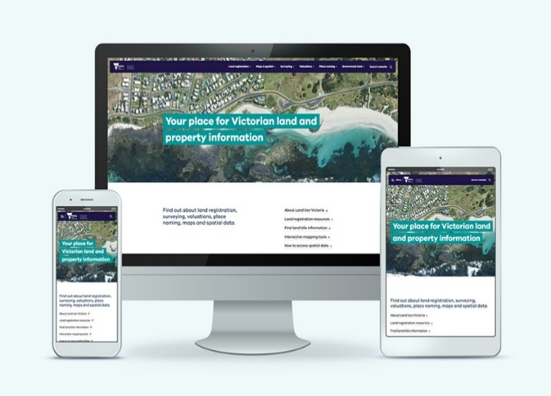
Land Use Victoria’s (LUV) new website for land and property information is now live. The new website has been redesigned to give users the best possible online experience through quicker access to the information they are looking for.
LUV has merged the former Maps and Spatial Data website with the Property and Land Titles website. The result is one trusted place for land and property information in Victoria.
The changes are based on customer insights and feedback. Our team worked with more than 2,500 customers and stakeholders to update our content and create a more seamless experience. The new site will make it easier to find land and property information.
Users will find all the important information they are used to plus so much more, in a simplified and streamlined website experience.
Some of the new features include:
- a user-focused website built around customer needs
- a simpler menu structure, with tailored content for specific users and a dedicated section for each service area
- refreshed content with more on latest news and LUV initiatives
- an HTML Customer Information Bulletin archive that is easier to browse
- all lodgment fees, guides and forms in one place and fully searchable
- more information on how to access our maps, spatial data and imagery
- improved profiling and search for interactive mapping tools
We have also been working to create a more consistent experience for customers across Victorian government websites. That’s why the new land.vic.gov.au look is in line with the Single Digital Presence .
Read more about what’s new in the website.

Naming rules for places in Victoria - review
Geographic Names Victoria (GNV) is undertaking a review of the naming rules for places in Victoria 2016 (the naming rules) as provided under Section 6 of the Geographic Place Names Act 1998 (the Act). The previous review was completed in 2015-16 and saw the creation of the 2016 naming rules. The 2020 review will see several amendments and proposed improvements.
A naming rules review committee has been created to guide the review process and a council reference group will provide insights and further suggestions. The nominated committee members include members of the Geographic Place Names Advisory Panel and emergency services personnel. GNV will be engaging with stakeholders in early December 2020 and as major stakeholders, your participation in the review process is invited. Stakeholder engagement will largely be managed through the state government's Engage.vic platform in December 2020 and early 2021.
A formal notice will be sent in coming weeks and we encourage you and relevant staff to review the Engage.vic site and submit comments. A draft document will be available for further comment later in 2021.
If you wish to provide comments directly to GNV please respond by 28 February 2021 via email to geo.names@delwp.vic.gov.au The current naming rules may be found online Naming rules for places in Victoria, Statutory requirements for naming roads, features and localities – 2016.

Digital Cadastre Modernisation project
The Digital Cadastre Modernisation (DCM) project is progressing, with an expanded team working on the cadastral queries that arise as Victoria’s land parcels are digitised and adjusted. Early November saw the milestone of the millionth fully digitised and quality assured property parcel; this provides the foundation for the Adjustment stage that has now commenced. Click here to keep up to date on the project.

Melbourne Strategic Assessment program
Notifications recorded under the Act
Land Use Victoria (LUV) has enhanced SPEAR to support the Melbourne Strategic Assessment (Environment Mitigation Levy) Act 2020 (MSA Act) which took effect on 1 July 2020.
Levy-affected land will be identifiable by a notice on the folio of the Register (title) similar to a Growth Areas Infrastructure Contribution (GAIC) Notice. The Registrar of Titles, on receiving an application from the Secretary under section 45 of the MSA Act, will record a notice stating that the environment mitigation levy may be payable. The MSA Act also provides for an application by the Secretary to remove a levy recording under section 47 of the MSA Act.
The MSA Act requires councils issuing a Statement of Compliance (SOC) for a subdivision of levy-affected land to provide a copy of the SOC and plan of subdivision to the Secretary of the Department of Environment, Land, Water and Planning (DELWP) for assessment. SPEAR will now automatically check whether the land being subdivided is affected by a notice under section 45 of the MSA Act and, where a notice exists, SPEAR will provide the required documents to DELWP. The Secretary must assess and consent to an application in SPEAR before the plan can be lodged at LUV.
Where a notice is to be removed in conjunction with a subdivision, the Secretary will create an application to remove a levy recording under section 47 of the MSA Act within the SPEAR workspace. Lodging parties will be able to view the application to remove a levy recording created by the Secretary and will need to lodge it together with the subdivision application and pay the applicable lodgment fee.
The lodgment fee for an application under section 47 of the MSA Act to remove a levy recording is $98.50 for the 2020-21 financial year.
For more information on the Melbourne Strategic Assessment program, please visit https://www.msa.vic.gov.au/ or email msa.habitatcompensation@delwp.vic.gov.au

Handy hints

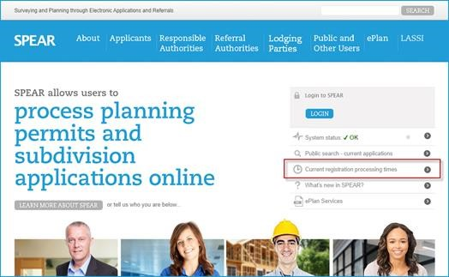
Plan examination updates
SPEAR users are reminded not to contact the SPEAR Service Desk for plan examination updates.
Once the ‘Pay & Lodge’ action in SPEAR has been completed, the application status will be updated to ‘Lodged at LUV’. This indicates the application is either in the queue to be examined OR it is being examined. SPEAR does not indicate when an application has been picked up for examination.
Land Use Victoria maintains a list of ‘Current registration processing times’ on the SPEAR website. This page also provides contact details for both the Subdivisions Branch and the Applications & Survey Branch should you wish to contact them regarding an application which has not been registered within the expected timeframe.
A quick link to the ‘Current registration processing times’ is available on the homepage of the SPEAR website.
SPEAR will notify you of any amendment requests (requisitions). Once the plan is registered, a notification will be sent advising of registration and a link to the new Volume and Folio details.

User profile settings
SPEAR offers a few profile settings to help streamline the way you access the system. These profile settings are individual and can be accessed from the ‘settings’ link in the blue SPEAR banner once you are logged in. Make sure to select the ‘Update User’ button to save your setting
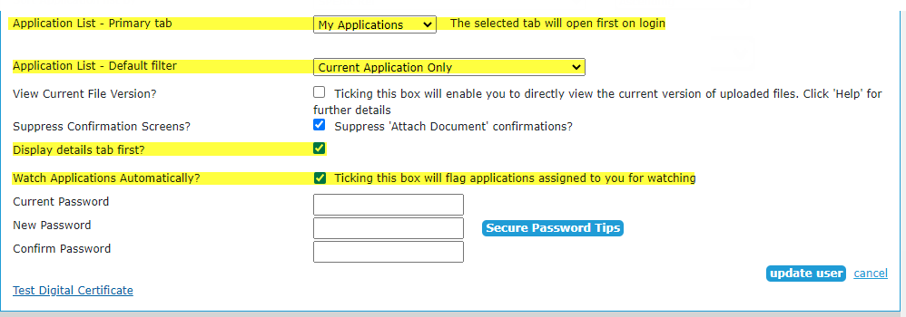
Watch Applications Automatically
Enable this checkbox to automatically flag applications assigned to you for watching. If an application is watched, any email notifications that are generated by those applications will also be copied to you.
Display Details tab first
Enable this checkbox to automatically open the Details screen of any application as the default view, regardless of how the application is accessed (Application List or email notification).
Application List – Default filter
Choose your default filter setting for the application list, i.e. All Applications, Current Applications, Active Applications or Completed Applications.
Application List – Primary tab
Choose which tab to view the Application List from, i.e. All Applications, My Applications or Watched Applications.
Contact Details
While you are reviewing your user settings, take a moment to ensure that your user contact details are correct, including email address. This should be your own email address, as this is the one used for ‘Watched Notifications’ and if you need to reset your password.

Stork visits the SPEAR team again!

Congratulations to Vernon Prasad and Hurdem on the safe arrival of their first child Jaan, born on 28 June 2020 at 6:18am.
Both parents feel very lucky to have spent precious time together at home with their gorgeous boy and getting to know one another. The Prasad family couldn’t wait to finally introduce him in person to all their family and friends after the easing of the lockdown restrictions.

SPEAR training 2021
The following dates have been scheduled for our quarterly online training sessions. If you wish to attend, please register for a session by contacting the SPEAR Service Desk on (03) 9194 0612.
Responsible Authority – council
Tuesday 9 February, Thursday 20 May, Tuesday 3 August, Thursday 18 November
Non-statutory referral authority
Tuesday 9 February, Thursday 20 May, Tuesday 3 August, Thursday 18 November
Lodging party
Wednesday 10 February, Wednesday 12 May, Wednesday 4 August, Wednesday 10 November
Applicant Contact
Thursday 18 February, Tuesday 11 May, Thursday 12 August, Tuesday 9 November
Statutory referral authority
Thursday 18 February, Tuesday 11 May, Thursday 12 August, Tuesday 9 November

Support
The SPEAR team wants to ensure your questions and issues are resolved quickly.
Contact the SPEAR Service Desk on (03) 9194 0612:
• Press 1 for SPEAR assistance
• Press 2 for Land Use Victoria subdivision lodgment enquiries
• Press 3 for ePlan enquiries
Contact SPEAR
T: 03 9194 0612

E: spear.info@delwp.vic.gov.au

W: www.spear.land.vic.gov.au
© The State of Victoria Department of Environment, Land, Water and Planning 2021  This work is licensed under a Creative Commons Attribution 4.0 International licence. You are free to re-use the work under that licence, on the condition that you credit the State of Victoria as author. The licence does not apply to any images, photographs or branding, including the Victorian Coat of Arms, the Victorian Government logo and the Department of Environment, Land, Water and Planning (DELWP) logo. To view a copy of this licence, visit http://creativecommons.org/licenses/by/4.0/  Disclaimer  This publication may be of assistance to you but the State of Victoria and its employees do not guarantee that the publication is without flaw of any kind or is wholly appropriate for your particular purposes and therefore disclaims all liability for any error, loss or other consequence which may arise from you relying on any information in this publication. | Accessibility  If you would like to receive this publication in an alternative format, please telephone the DELWP Customer Service Centre on 136186, email customer.service@delwp.vic.gov.au, or via the National Relay Service on 133 677 www.relayservice.com.au. This document is also available on the internet at www.spear.land.vic.gov.au.
Alternatively, you can send your enquiry by email to spear.info@delwp.vic.gov.au

